Vietnam National University Ho Chi Minh City

Ho Chi Minh City of Technology

Computer Science and Engineering Faculty



SOFTWARE ENGINEERING

ASSIGNMENT 2

Professor: Bui Hoai Thang

Student: Luong Thanh Nhan – 1820047 – Class B01

Group 4

10/2019

Contents

**Part 1: ASSIGNMENT 1 6**

1. Introduction (Group work) 6

1.1. Purposes 6

1.2. Definitions 6

1.3. Overview 6

2. Overall Description (Group work) 6

2.1. System Use Case Diagram 6

2.2. System Context Diagram 9

3. Functional Requirement Specifications (Group work) 9

3.1. Room Information and Schedule 9

3.1.1. Search room for information 9

3.1.2. Search room for booking 9

3.1.3. Book room 9

3.1.4. Cancel room 10

3.1.5. Modify room 10

3.1.6. Review booking 10

3.1.7. Confirm by email 10

3.1.8. Remind by email 10

3.1.9. Campus map 10

3.1.10. Recommend room 10

3.1.11. Search Lecturer 10

3.1.12. Borrow Laboratory 10

3.2. Electrical Automation System 11

3.2.1. Turn on automatically 11

3.2.2. Turn off automatically 11

3.2.3. Alert not functional 11

3.2.4. Alarm automatically 11

3.3. Security Staff 11

3.3.1. Search for electrical devices 11

3.3.2. Search for active room 11

3.3.3. Control electrical devices remotely 11

3.3.4. Control electrical devices in-person 11

3.3.5. Monitor camera 11

3.3.6. Enter the Campus 12

3.4. Sensor and Camera System 12

3.4.1. Check number of people 12

3.4.2. Automatically control the light 12

3.4.3. Alert detecting human 12

3.4.4. Detect fire 12

3.5. SOS Alert 12

3.6. Statistical and Reporting System 12

3.6.1. View electrical usage 12

3.6.2. View room usage 12

3.6.3. Automatically send report 12

3.6.4. User feedback 13

4. Non-Functional Requirements Specification (Group work and Individual work) 13

4.1. Group work - Non-Functional Requirements Specification 13

4.1.1. Efficiency requirements 13

4.1.2. Regulatory 14

4.1.3. Usability 14

4.1.4. Reliability 14

4.1.5. Confidentiality 14

4.1.6. Survivability 15

4.2. Individual - Other Non-Functional Requirements 15

5. Use-case detail/scenario for use-case and specific non-function requirement (Individual work) 16

5.1 Check Number Of People 16

5.1.1. Context Model: 16

5.1.2. Use case diagram: 16

5.1.3. Use case scenario tabular: 17

5.1.4. Non-function requirement 18

5.2 Send SOS 18

5.2.1. Context Model: 18

5.2.2. Use-case Diagram: 19

5.2.3. Use case scenario tabular: 19

5.2.4. Non-functional requirement 20

5.3. Borrow Equipment 20

5.3.1. Context Model: 20

5.3.2. Use-case Diagram: 20

5.3.3. Use case scenario tabular: 21

5.3.4 Non-functional requirements 21

5.4. Search for Lecturer 22

5.4.1. Context Model: 22

5.4.2. Use-case Diagram: 22

5.4.3. Use case scenario tabular: 22

5.4.4 Non-functional requirement 23

5.5. Get Identification 24

5.5.1. Context Model: 24

5.5.2. Use-case Diagram: 24

5.5.3. Use case scenario tabular: 24

5.5.4 Non-functional requirement 25

5.6. Verify Identification 25

5.6.1. Context Model: 25

5.6.2. Use-case Diagram: 25

5.6.3. Use case scenario tabular: 26

5.6.4 Non-functional requirement 26

6. Other non-interactive functional requirement (Individual work) 27

6.1. Send notifications about quotes 27

6.2. Remind exam schedule. 27

6.3. Check students’ attendance 27

7. Conclusion (Individual work) 27

**Part 2: ASSIGNMENT 2 28**

1. Sequence Diagram 28

1.1 Check Number of People 28

1.2 Send SOS 30

1.3 Borrow Equipment 32

1.4 Search for Lecturer 34

1.5. Get Identification 36

1.6 Verify Identification 38

2. State-chart Diagram 40

2.1 Lab equipment state-chart diagram 40

3. Activity Diagram 42

3.1 Verify identification activity 42

3.2 Borrow lab equipment activity 43

3.3 Check number of people activity 44

3.4 Send SOS activity 45

4. Conclusion 46

5. Group list 46

# Part 1: ASSIGNMENT 1

# 1. Introduction (Group work)

## 1.1. Purposes

The purpose of this report is specifying a Smart Campus System (SCAMS) in detail including system design, features, methods and operation of the system and how the system interacts with variety range of users such as lecturers, students, security staffs,guesses. The system is expected to make the university smart.

## 1.2. Definitions

SCAMS: Smart Campus System

## 1.3. Overview

* Section 1: Group work - Introduction to the SCAMS
* Section 2: Group work - Overall description of the SCAMS
* Section 3: Group work and individual work - Functional requirements
* Section 4: Group work and individual work - Non-Functional requirements
* Section 5: Individual - Use-case detail/scenario for use-case the student is in-charged
* Section 6: Individual - Non-interactive functional requirements
* Section 7: Individual – Conclusion
* Section 8: Further notes

# 2. Overall Description (Group work)

## 2.1. System Use Case Diagram

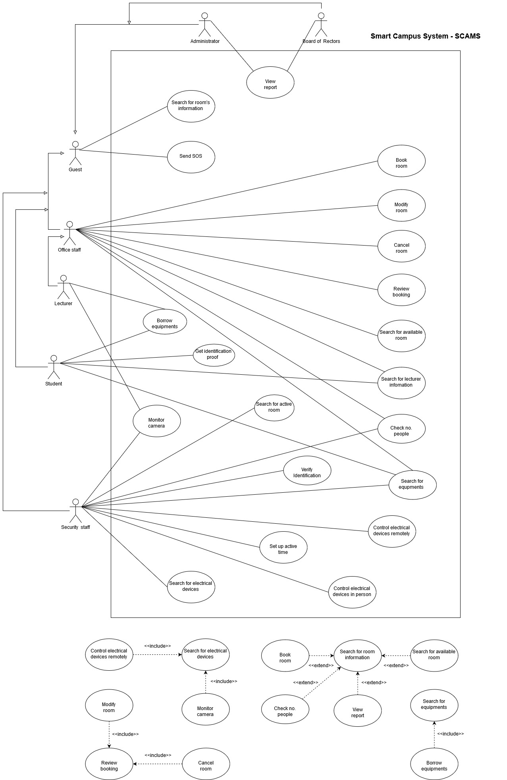

*Figure 1.1: System Use-case Diagram For Smart Campus System (SCAMS)*

The SCAMS system includes/connects to the following components:

* **Room Information and Schedule**: connects Room Management Service (ROMS) of the university to fetch room data, book and modify room for different purposes.
* **IoT system**: connects to the IoT system of the university to view information, control electrical devices.
* **User Database System**: connects to the User Database System of the university to fetch user information and verify user.
* **Infrastructure Database**: connects to the Infrastructure Database of the university to fetch infrastructure and facility information .
* **AI service**: connects to the external AI service for detecting human.
* Emailing System: connects to the external email service to send email automatically to users and other stakeholders.
* **End User Interface System**: includes a system of interfaces for end user on different platforms.
* **Statistics and Reports System**: includes a systems of statistics and reports for different purposes.

End-users of SCAMS system:

* Lecturers
* Security Staffs
* Office Staffs
* Students
* Guests
* Board of Rectors
* System Administrators

## 2.2. System Context Diagram

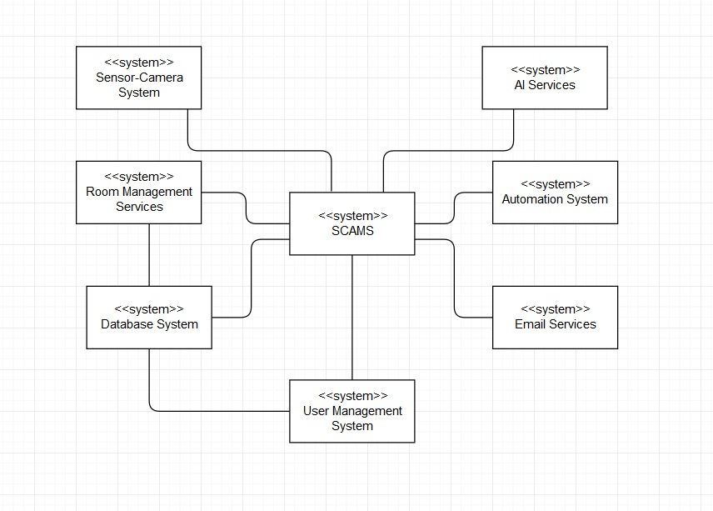

*Figure 1.2: Context-model Diagram*

# 3. Functional Requirement Specifications (Group work)

## 3.1. Room Information and Schedule

### 3.1.1. Search room for information

All users can search for room information (available or not, capacity, current lecture/event information, direction to the room) using date, building, room number.

### 3.1.2. Search room for booking

Lecturers and office staff can search room to see its information (available or not, capacity) for booking purpose, using search criteria: date, building, room number.

### 3.1.3. Book room

Lecturers and office staff can book a room in one or more class periods for different purposes (teaching, event).

### 3.1.4. Cancel room

Lecturers and office staff can cancel a room they booked if they change their schedule.

### 3.1.5. Modify room

Lecturers and office staff can modify a room they booked if they change their schedule.

### 3.1.6. Review booking

Lecturers and office staff can review all of their booked rooms on the application

### 3.1.7. Confirm by email

Email will be sent to the lecturer/office staff email address when he/she finished booking/modify/canceling room.

### 3.1.8. Remind by email

User (lecturer & office staff) will receive a reminder of his/her booked room's information & schedule before the lecture.

### 3.1.9. Campus map

User can open the whole campus map on the application.

### 3.1.10. Recommend room

The system recommend lecturer the suitable room for them.

### 3.1.11. Search Lecturer

Lecturers, Students, Office Staff and Security Staff can search for lecturers information.

### 3.1.12. Borrow Laboratory

User can register for borrowing laboratory equipment.

## 3.2. Electrical Automation System

### 3.2.1. Turn on automatically

The doors and its electrical (lights, fans) devices will be turned on automatically before the lecture if they are off.

### 3.2.2. Turn off automatically

Electrical devices will be turned off and doors will be closed after the end of lecture & after the last person left the room if there are no next lecture in the same room.

### 3.2.3. Alert not functional

An alert will be sent to the security staff if doors the automation system is function properly (not on or of as it has to be).

### 3.2.4. Alarm automatically

The sound will be alarmed at if there is still some person in the room after the closed hour of the university.

## 3.3. Security Staff

### 3.3.1. Search for electrical devices

Security staff can search for electrical devices by room's ID, building's ID.

### 3.3.2. Search for active room

Security can search for rooms in the campus which is still in active after the closed hour.

### 3.3.3. Control electrical devices remotely

Security staff can control electrical devices using the application.

### 3.3.4. Control electrical devices in-person

Security staff use code on the system to access control panel attached on each room, corridor, building to control in-person.

### 3.3.5. Monitor camera

User (security staff) can monitor rooms, corridor and building using camera.

### 3.3.6. Enter the Campus

User can use the changeable QR code provided by the system to verify identification in order to enter the campus instead of using the ID card.

## 3.4. Sensor and Camera System

### 3.4.1. Check number of people

User can check for the number of people in the classroom currently.

### 3.4.2. Automatically control the light

The lights in corridors can be turned on/off automatically based on human detecting system.

### 3.4.3. Alert detecting human

The system can send an alert to the security staff in case of detecting human.

### 3.4.4. Detect fire

The system is able to detect fire based on a system of sensor detecting smoke and fire.

## 3.5. SOS Alert

User can send SOS alert to every user in the campus if he/she is in danger.

## 3.6. Statistical and Reporting System

### 3.6.1. View electrical usage

System Administrators and Board of Rectors can view reports on the usage of electrical devices.

### 3.6.2. View room usage

System Administrators and Board of Rectors can view reports on the usage of electrical devices in a period of time.

### 3.6.3. Automatically send report

A monthly report will be generated and sent automatically to the System Administrators and the Board of Rectors via email.

### 3.6.4. User feedback

Any user can provide information and suggestions about the use of electrical devices to the System Administrators using the reporting box.

# 4. Non-Functional Requirements Specification (Group work and Individual work)

## 4.1. Group work - Non-Functional Requirements Specification

### 4.1.1. Efficiency requirements

* Response Time:
* The maximum start up time of the system is 2 seconds
* The maximum receiving search result time is 4 seconds.
* The maximum react time of the system for a particular job is 2 seconds.
* The doors and its electrical (lights, fans) devices will be turned on automatically 15 minutes before the lecture if they are off.
* Electrical devices will be turned off and doors will be closed immediately after the end of lecture & after the last person left the room if there are no next lecture in the same room.
* Report for System Administrator and Board of Rectors will be generated before 5pm on the last working day of the month.
* The maximum interaction for each activity (searching, booking, cancelling, modifying, monitoring, SOS messaging, report retrieving) is 2.
* Space:
* At least 20 percent of the processor capacity and storage space available to the system shall be unused at normal load seasonal periods.
* Performance:
* At least 80 percent of the request must be successful in 1 minute.

### 4.1.2. Regulatory

* The system shall not affect other system while using shared resources.

### 4.1.3. Usability

* User Interface:
* The interface must be available in English and Vietnamese.
* Learnability:
* The product shall be able to used by adult members (age 18 to 60) without training.

### 4.1.4. Reliability

* Readiness:
* The system shall be at least 99 percent available everyday, maintenance is not included.
* Unless the system is non‐operational, the system shall send a user an email informing them that the system is unavailable.
* Fault tolerance:
* The system should ensure operation in case of errors.
* Resilience:
* The system should recover operation in at most 3 hours in case of incidents.

### 4.1.5. Confidentiality

* Security:
* The system should provide multi-layer security for accessing management tools.
* Integrity:
* Username and password of users should be encrypted.
* Authentication:
* The system should provide two-factor authentication.
* The system should authenticate by a sequence of 4 numbers (PIN) besides password.

### 4.1.6. Survivability

* Analytical ability:
* The system should be able to identify issues itself and provide reports.
* Modifiability:
* In source code, function calls shall not be nested more than two levels deep.
* A junior developer who has at least 6 months of experience programming should be able to add a new feature, including code modifications and testing.
* Adaptation ability:
* The system can operate on several platforms: web and mobile.
* The system should display on different resolution based on devices.
* The system must be able to interface with any HTML (HyperText Markup Language) browser.
* Installability:
* The system should be installed easily and automatically.
* The installation time must be within 5 minutes.
* When a new version of the main system is released, it shall be possible to upgrade to it from any previous version.

## 4.2. Individual - Other Non-Functional Requirements

* The action of controlling the devices can be transfer to another security staff or their supervisor in case of the current one can not be able to do it.
* The notification of abnormal room will be pushed to security staff’s mobile phone after closed hour if they exist.
* The number of people in room must be refreshed in every 30 seconds.

*And some specific non-functional requirements in the next section (section 5)*

# 5. Use-case detail/scenario for use-case and specific non-function requirement (Individual work)

## 5.1 Check Number Of People

### 5.1.1. Context Model:

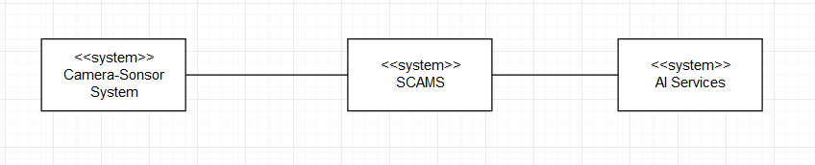

*Figure 1.3: Context model for checking number of people*

### 5.1.2. Use case diagram:

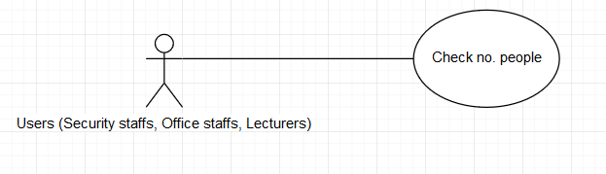

*Figure 1.4: Use-case Diagram for checking number of people*

### 5.1.3. Use case scenario tabular:

|  |  |
| --- | --- |
| Use case name | Check no. people |
| Actor | Security staffs, Office staffs, Lecturers |
| Description | The users can check the number of people in a class for many reasons such as:   * When lecturers are not in the class while Teaching Assistant is taking that class. The lecturer can check if the class if full of students or not. * Security staffs can check for security issues in self-study rooms. * The office staff who is not able to join an event at a room directly can check if the room is full of attendant or not. |
| Preconditions | The users logged in into SCAMS application and is at the SCAMS homepage |
| Triggers | None |
| Normal Flow | 1. Users selects “Search” on SCAMS home page 2. System represents a search panel with multiple filters (date) and (building, room number). Date and building must be filled 3. Users selects date, building and room’s number from filters and then click/touch on “Search” button. 4. System represents room’s information including room’s number, the building and a button “Check No. People” (which is only enabled for Security staffs, Office staffs and Lecturers) next to it. 5. Users click/touch on “Check No. People” button 6. System lets users know the number of people in the class by showing a pop-up. 7. Users quit the pop-up 8. Users quit page 9. Users return to homepage |
| Exception | *Exception at step 5.*  The AI services provided by external company doesn’t work. The system will display a pop-up notifying “This Service Is Not Available” |
| Alternative Flows | *Alternative 1: at step 3 and step 4*  3a. Users select building  3b. System represents a list of several room’s information including number of rooms which are located in that building and a button “Check No. People” (which is only enabled for Security staffs, Office staffs and Lecturers) next to it.  *Continue step 5 in the normal flow*  *Alternative 2: at step 3 and step 4*  3a. Users select room  3b. System represents a list of several room’s information including name of the building whom they are located in and a button “Check No. People” (which is only enabled for security staffs, office staffs and lecturers) next to it.  *Continue step 5 in the normal flow* |

### 5.1.4. Non-function requirement

The system has to make sure that only security staffs, office staffs and lecturers have access to this features.

The system has to make sure that it operates constantly 99 percent of all time.

## 5.2 Send SOS

### 5.2.1. Context Model:

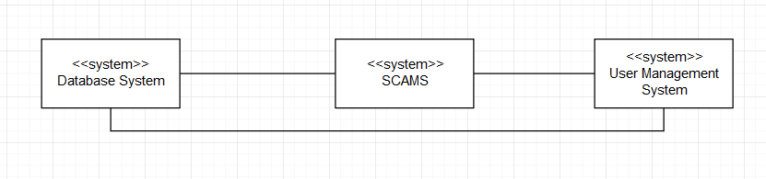

*Figure 1.5: Context model for sending SOS*

### 5.2.2. Use-case Diagram:

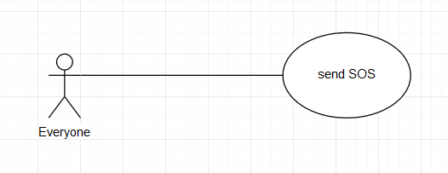

*Figure 1.6: Use-case Diagram for sending SOS*

### 5.2.3. Use case scenario tabular:

|  |  |
| --- | --- |
| Use case name | Send SOS |
| Actor | Everyone |
| Description | The users can send a SOS alert to everyone else in the system in case of emergency:   * When users are in a dangerous situation (the campus is huge, so evildoers can attack users for robbing) |
| Preconditions | The users logged in into SCAMS application and is at the SCAMS homepage |
| Triggers | None |
| Normal Flow | 1. Users selects tab “SOS” on SCAMS home page  2. System represents a page with text input field and a red button  3. Users fill the content  4. Users tap twice on the red button  5. System represents a pop-up with a notification “Send SOS Successfully” |
| Exception | *Exception at step 4:*  If the input is not filled, a default content will be sent  *Exception at step 5:*  The alert cannot be sent (alternative 2). |
| Alternative Flows | *Alternative 1: at step 3*  3a. User skip this step and move to step 4  *Continue step 4 in the normal flow*  *Alternative 2: at step 5*  5a. System represents a pop-up with a notification “Fail to send SOS” and a button “Try again”  5b. Users click/tap on the button  *Continue until step 5 in the normal flow* |

### 5.2.4. Non-functional requirement

The system has to make sure that SOS alert will be sent with 99 percent of success.

## 5.3. Borrow Equipment

### 5.3.1. Context Model:



*Figure 1.7: Context model for borrowing equipment*

### 5.3.2. Use-case Diagram:

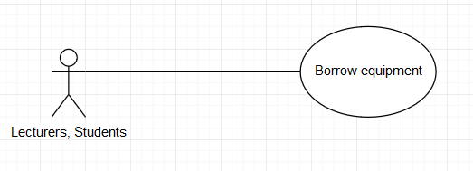

*Figure 1.8: Use-case Diagram for borrowing equipment*

### 5.3.3. Use case scenario tabular:

|  |  |
| --- | --- |
| Use case name | Borrow equipment |
| Actor | Lecturers, Students |
| Description | The users can borrow equipment for working purpose |
| Preconditions | The users logged in into SCAMS application and is at the SCAMS homepage |
| Triggers | None |
| Normal Flow | 1. Users selects tab “Equipment” on SCAMS home page  2. System represents a page with a list of equipment and their ID, name, location and status (available or not) and a “Search” field which contains “ID” and “Name” filters.  3. Users choose the equipment from the list  4. System represents a page with a form including input “Borrowing time”, “Reason”.  5. Users fill in the form  6. Users click/tap “request” button  7. System represents a page with a notification “request is pending”  8. Users quit page  9. Users return to homepage |
| Exception | *None* |
| Alternative Flows | *Alternative 1: at step 2*  3a. Users fill ID or name of the equipment in the field.  3b. Users click/tap “Search” button  3c. System represents a page with a list of equipment and their name, ID, location and status (available or not)  *Continue step 3 in the normal flow* |

### 5.3.4 Non-functional requirements

The system has to make sure that the borrowing request should be processed in 1 hour.

The system has to make sure that it operates constantly 99 percent of all time.

## 5.4. Search for Lecturer

### 5.4.1. Context Model:



*Figure 1.9: Context model for searching for lecturer*

### 5.4.2. Use-case Diagram:

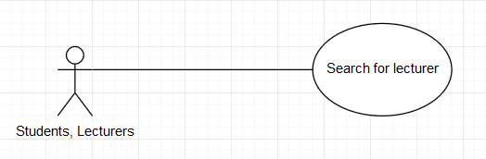

*Figure 1.10: Use-case Diagram for searching for lecturer*

### 5.4.3. Use case scenario tabular:

|  |  |
| --- | --- |
| Use case name | Search for lecturer |
| Actor | Students, Lecturers |
| Description | The users can search for lecturer’s information for contacting purpose such as:   * Portrait photo * Class’s schedule * Email * Phone number * Working room location |
| Preconditions | The users logged in into SCAMS application and is at the SCAMS homepage |
| Triggers | None |
| Normal Flow | 1. Users selects tab “Lecture Information” on SCAMS home page  2. System represents a page with a “Search” field which contains “ID”, “Name”, “Faculty” filters.  3. Users fill in the inputs  4. Users click/tap “Search” button.  5. System represents a page with a list of lecturer’s information that all matches with ID, name and faculty.  6. Users choose lecturer  7. System represents a page with the lecturers’ information in detail.  8. Users search for information that needed  9. Users quit page  10. Users return to homepage |
| Exception | *Exception at step 4: at step 3*  Users do not fill in the field (alternative 2) |
| Alternative Flows | *Alternative 1: at step 3*  3a. Users only fill ID or name or faculty in the field  3b. Users click/tap “Search” button  3c. System represents a page with a list of lecturer’s information that only matches ID or name or faculty.  *Continue step 6 in the normal flow*  *Alternative 2: at step 3*  3a. Users do not fill in the field  3b. Users click/tap “Search” button  3c. System represents a page with a list of all lecturers’ information  *Continue step 6 in the normal flow* |

### 5.4.4 Non-functional requirement

The system should have a friendly UI design; content should be readable by people who are color blind.

The system has to make sure that it operates constantly 99 percent of all time.

## 5.5. Get Identification

### 5.5.1. Context Model:



*Figure 1.11: Context model for Getting identification*

### 5.5.2. Use-case Diagram:

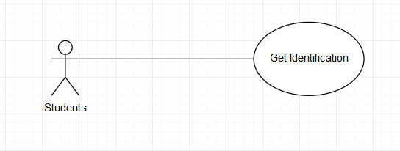

*Figure 1.12: Use-case Diagram for getting identification*

### 5.5.3. Use case scenario tabular:

|  |  |
| --- | --- |
| Use case name | Get Identification |
| Actor | Students |
| Description | The users can get a proof of identification |
| Preconditions | The users logged in into SCAMS application and is at the SCAMS homepage |
| Triggers | None |
| Normal Flow | 1. Users selects tab “Profile” on SCAMS home page  2. System represents a page with profile of the student  3. Users click/tap “Get Identification” button  4. System represent a pop-up with a QR code  5. Users show the code for security staff to scan  6. The system represent a page with a notification which notifies valid identification  7. Users quit page  8. Users return to homepage |
| Exception | *None* |
| Alternative Flows | *None* |

### 5.5.4 Non-functional requirement

The system has to make sure that the QR code should change every day for security purpose.

The system has to make sure that it operates constantly 99 percent of all time.

## 5.6. Verify Identification

### 5.6.1. Context Model:



*Figure 1.13: Context model for verifying identification*

### 5.6.2. Use-case Diagram:

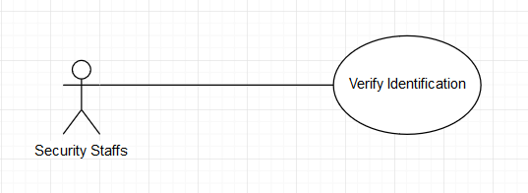

*Figure 1.14: Use-case Diagram for verifying identification*

### 5.6.3. Use case scenario tabular:

|  |  |
| --- | --- |
| Use case name | Verify Identification |
| Actor | Security Staffs |
| Description | The security can check if a people is a valid student or not |
| Preconditions | The users logged in into SCAMS application and is at the SCAMS homepage |
| Triggers | None |
| Normal Flow | 1. Users selects tab “Profile” on SCAMS home page  2. System represents a page with profile of the security staff  3. Users click/tap “Verify Identification” button  4. System represent a camera interface for scanning students’ QR code  5. Users scan the QR code which is provided by the student  6. The system represent a page with a notification which notifies valid identification  7. Users quit page  8. Users return to homepage |
| Exception | *Exception 1 at step 6:*  The system represents a page with a notification which notifies invalid identification  *Exception 2 at step 6:*  The system does not recognize the QR code (alternative 1) |
| Alternative Flows | *Alternative 1: at step 6*  6a. System represents a pop-up with “send report” button  6b. Users click/tap on the button  *Continue step 7 in the normal flow* |

### 5.6.4 Non-functional requirement

The system has to make sure that only security staffs have this ability and it can recognize the code immediately.

The system has to make sure that it operates constantly and accurately 99 percent of all time.

# 6. Other non-interactive functional requirement (Individual work)

## 6.1. Send notifications about quotes

On the mobile phone, SCAMS application is able to send a notification about quotes by famous people to lock screen periodically and automatically

## 6.2. Remind exam schedule.

System is able to automatically send a notification which reminds students for upcoming exam schedule.

## 6.3. Check students’ attendance

The system is able to check students’ attendance through camera system and AI services, and then automatically send a report to lecturers who is responsible for that class.

# 7. Conclusion (Individual work)

After team-working and personal working. This report has completed tasks in assignment-1 about functional requirements and non-functional requirements.

# Part 2: ASSIGNMENT 2

# 1. Sequence Diagram

## 1.1 Check Number of People

* Brief Description:
* Users open search page
* Users fill in the fields
* Users search for room to check number of people
* SCAMS get data from camera system
* SCAMS transfer data from camera system to AI Service
* AI Service operates for counting number of people
* AI Service return number of people to SCAMS
* SCAMS display number of people to users
* Sequence Diagram:

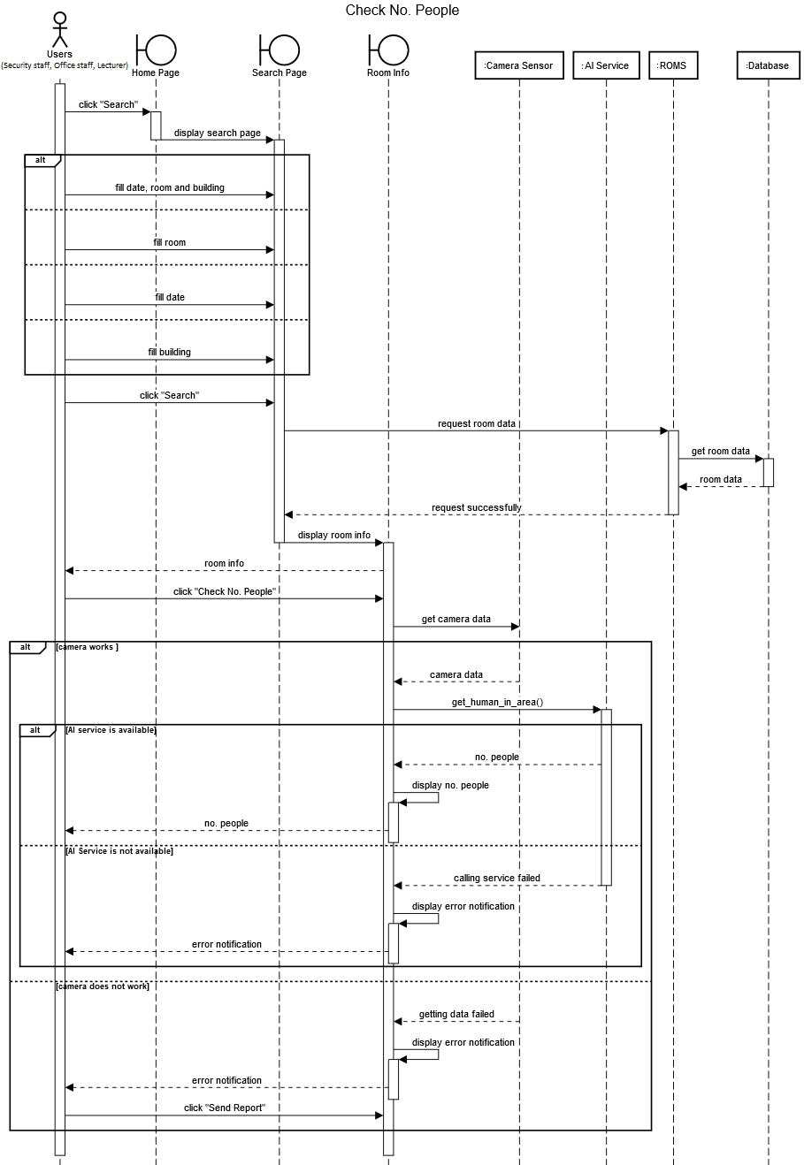

*Figure 2.1: Sequence diagram for checking no. people*

## 1.2 Send SOS

* Sequence Diagram:

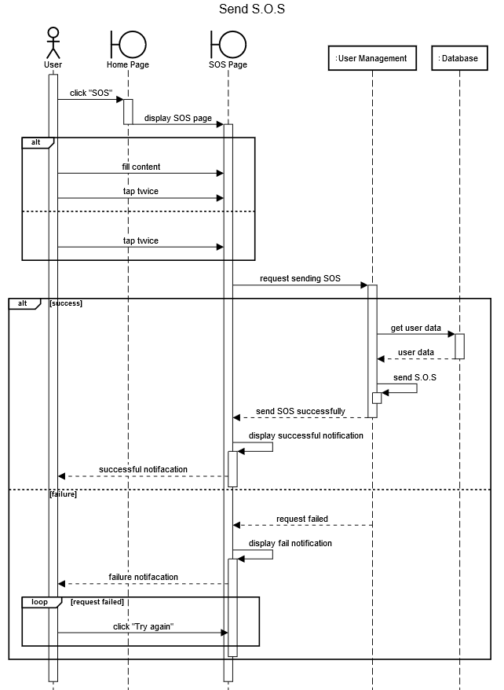

*Figure 2.2: Sequence diagram for sending SOS*

* Brief Description:
* Users open SOS page
* Users fill form (optional)
* Users tap twice on the screen to request sending SOS
* SCAMS send request to User Management System
* User Management System operates sending SOS
* User Management System return the result to SCAMS
* SCAMS display notification to users

## 1.3 Borrow Equipment

* Sequence Diagram:

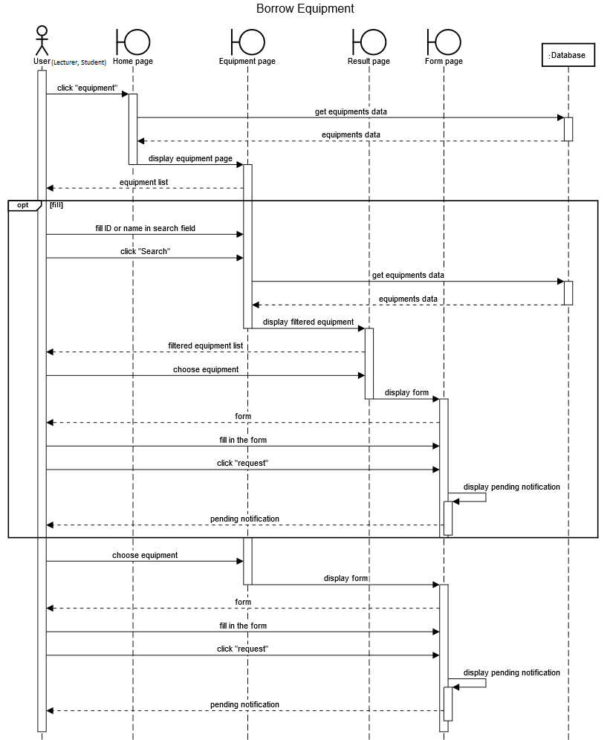

*Figure 2.3: Sequence diagram for borrowing equipment*

* Brief Description:
* Users open equipment page
* Users fill in the fields (optional)
* Users search for the equipment (optional)
* SCAMS display a list of equipment
* Users choose equipment
* Users request for borrowing
* SCAMS display notification to users

## 1.4 Search for Lecturer

* Sequence Diagram:

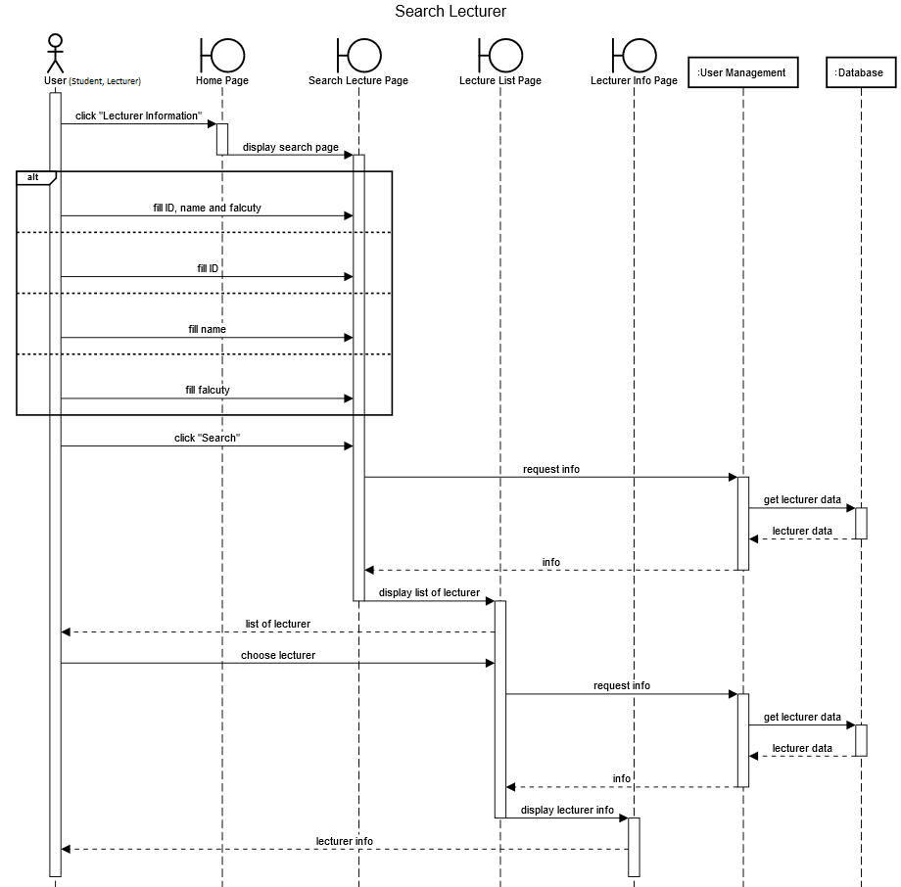

*Figure 2.4: Sequence diagram for searching for lecturer*

* Brief Description:
* Users open lecturer page
* Users fill in the fields
* Users search for lecturer
* SCAMS display a list of lecturer
* Users choose a lecturer to see information
* SCAMS display lecturer information to users

## 1.5. Get Identification

* Sequence Diagram:

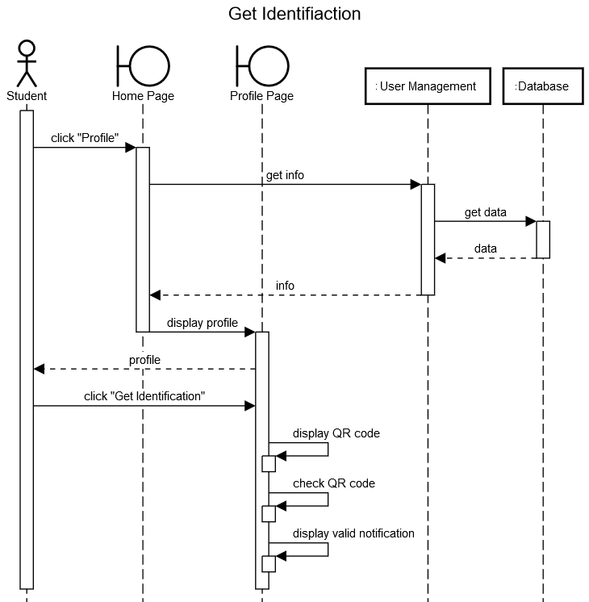

*Figure 2.5: Sequence diagram for getting identification*

* Brief Description:
* Users open profile page
* Users click “get identification”
* SCAMS create a QR code
* Users use the QR code to verify identification
* SCAMS display notification to users

## 1.6 Verify Identification

* Sequence Diagram:

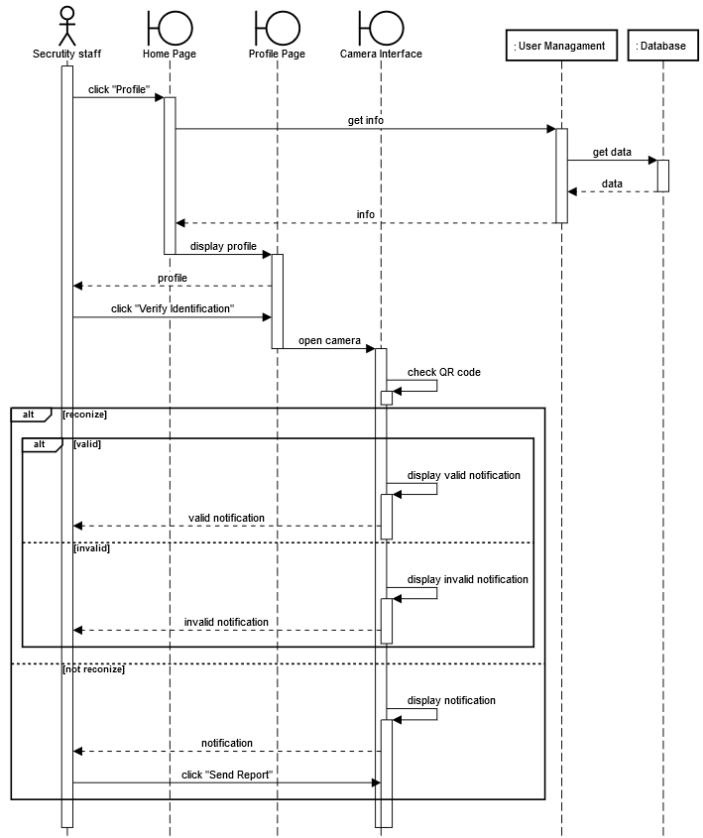

*Figure 2.6: Sequence diagram for verifying identification*

* Brief Description:
* Users open profile page
* Users click “verify identification”
* SCAMS represent a camera interface
* Users scan QR code which provided by the student
* SCAMS check QR code
* SCAMS display notification to users

# 2. State-chart Diagram

## 2.1 Lab equipment state-chart diagram

* State-chart diagram:

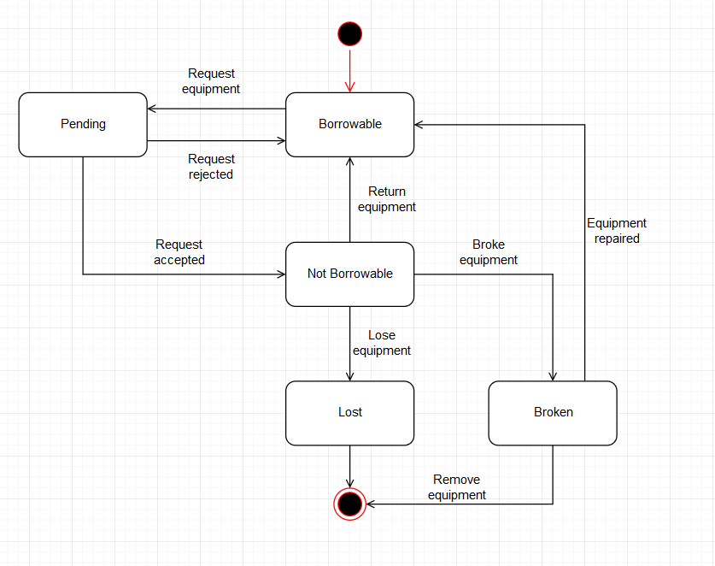

*Figure 2.7: State-chart diagram for lab equipment*

* State tabular:

|  |  |
| --- | --- |
| State | Description |
| Borrowable | The equipment is available for borrowing |
| Not borrowable | The equipment is not available for borrowing |
| Pending | The equipment is waiting for confirming |
| Lost | The equipment is now lost |
| Broken | The equipment is now broken |

* Stimulus tabular:

|  |  |
| --- | --- |
| Stimulus | Description |
| Request equipment | The user requests for borrowing equipment |
| Accept request | The office staff accepts request |
| Reject request | The office staff rejects request |
| Return equipment | The user return equipment |
| Lose equipment | The user loses equipment |
| Broke equipment | The user makes equipment broken |
| Repair equipment | The equipment has been repaired |
| Remove equipment | The office staff remove the equipment |

# 3. Activity Diagram

## 3.1 Verify identification activity

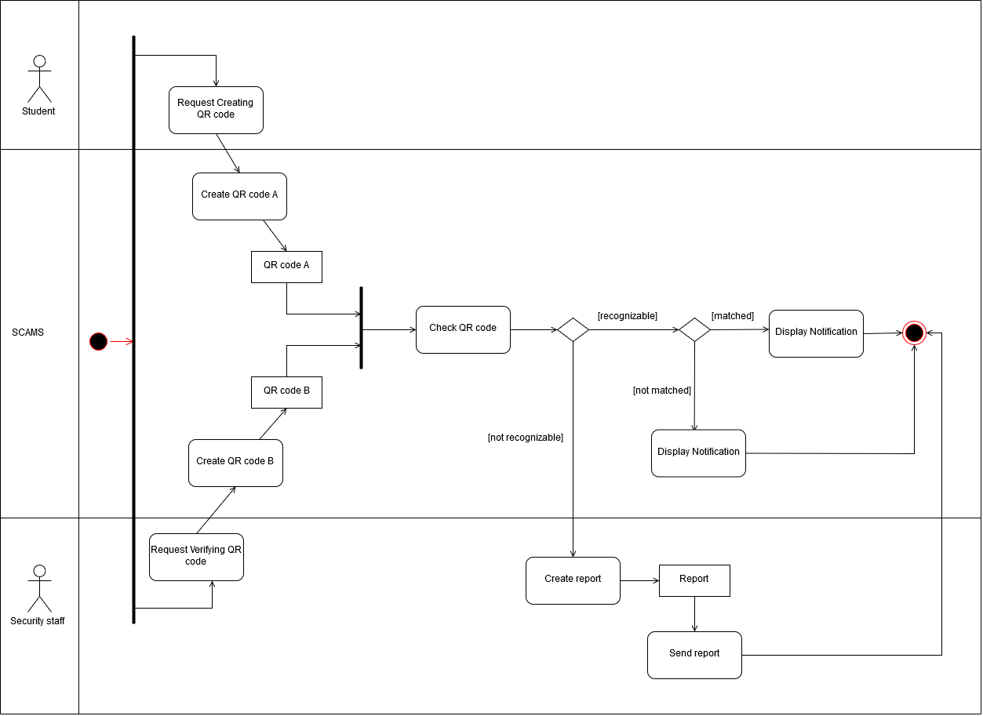

*Figure 2.8: Activity diagram for verifying identification*

## 3.2 Borrow lab equipment activity

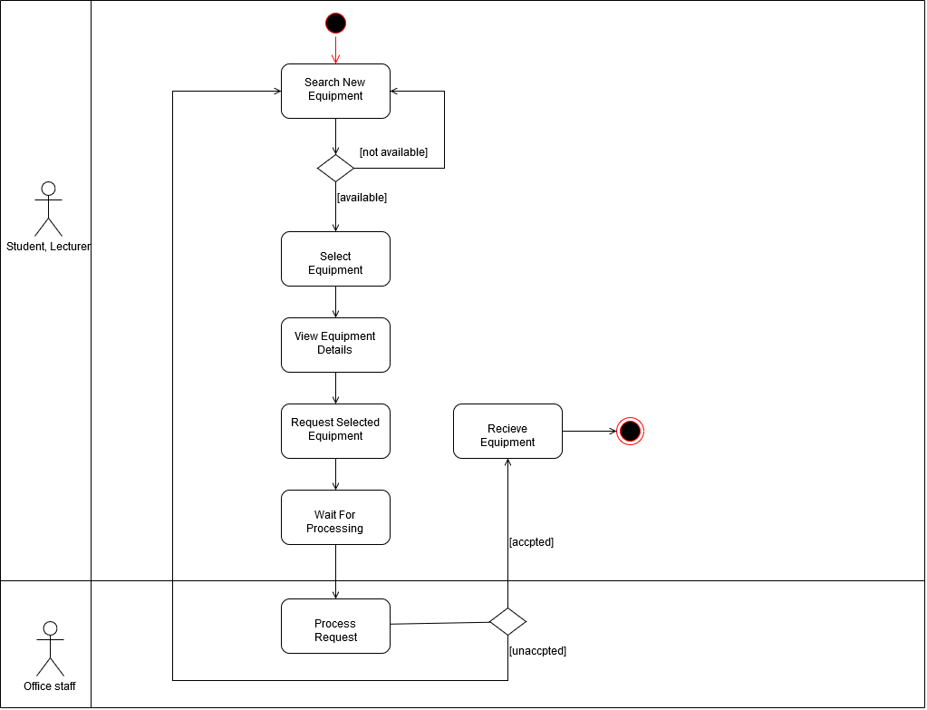

*Figure 2.9: Activity diagram for borrowing lab equipment*

## 3.3 Check number of people activity

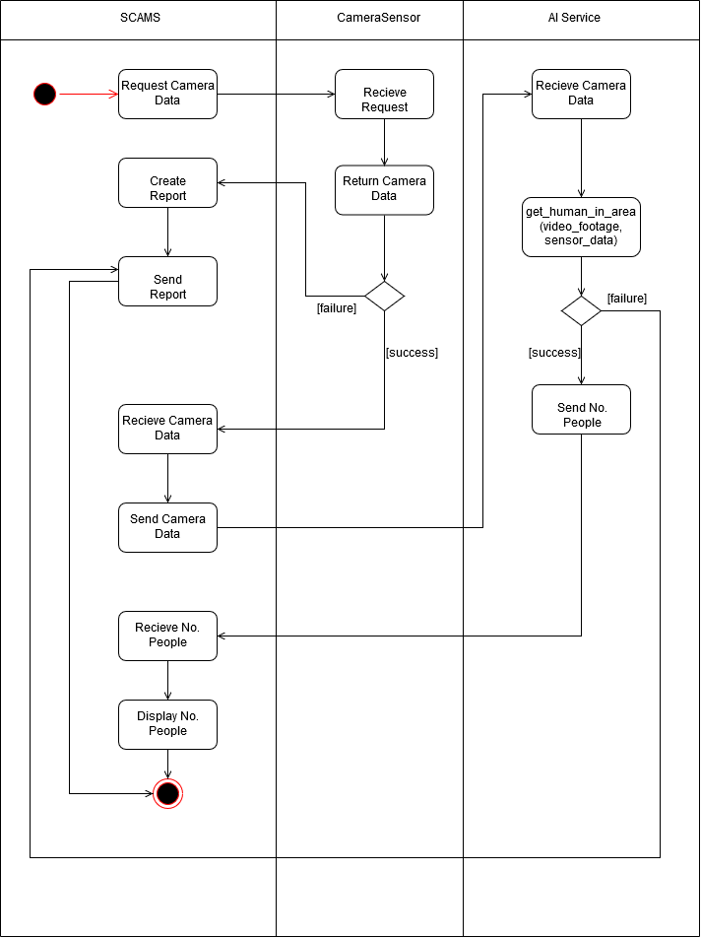

*Figure 2.10: Activity diagram for checking number of people*

## 3.4 Send SOS activity

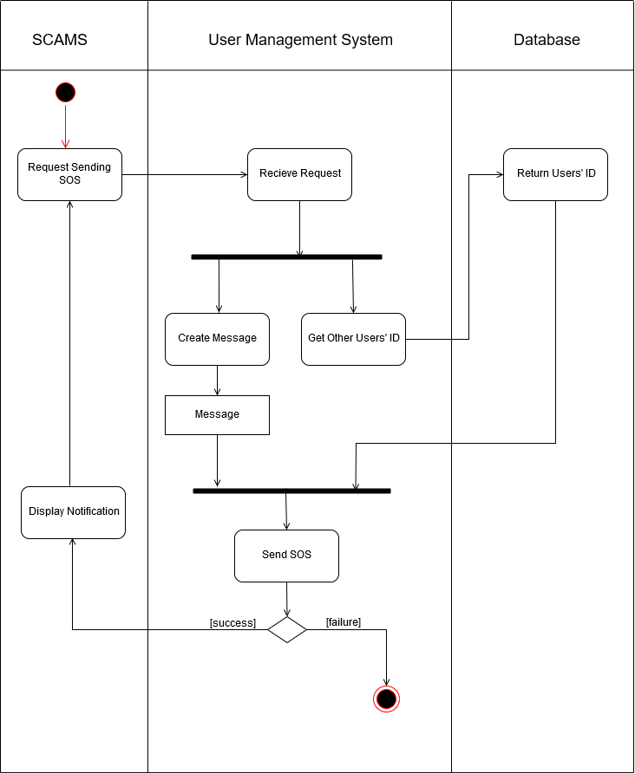

*Figure 2.11: Activity diagram for sending SOS activity*

# 4. Conclusion

This report has completed tasks in assignment-2 about sequence diagram, state-chart diagram and activity diagram

# 5. Group list

|  |  |  |
| --- | --- | --- |
| Name | Student’s ID | Distribution |
| Tran Thi Ngoc Diep | 1827005 | 100% |
| Ngo Hoang Ngoc Thanh | 1827030 | 100% |
| Pham Tran Dinh Huy | 1820031 | 100% |
| Nguyen Dang Khoa | 1820034 | 100% |
| Luong Thanh Nhan | 1820047 | 100% |